Online School Portal
https://students.ashworthcollege.edu/dashboard
Username: Carriegilles@ymail.com
Password: 133Pinson

Sign in
Click on English 4: Part 1 General Program
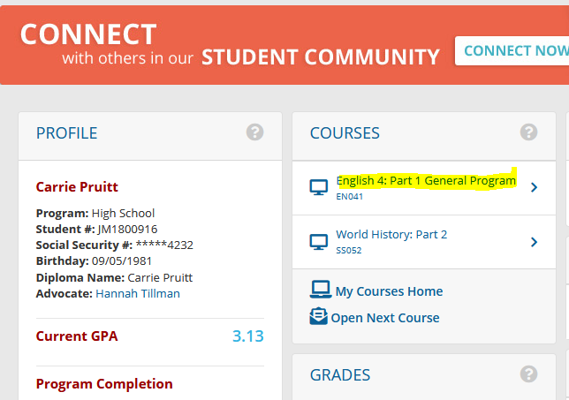

Click on Assessments
- Assignments

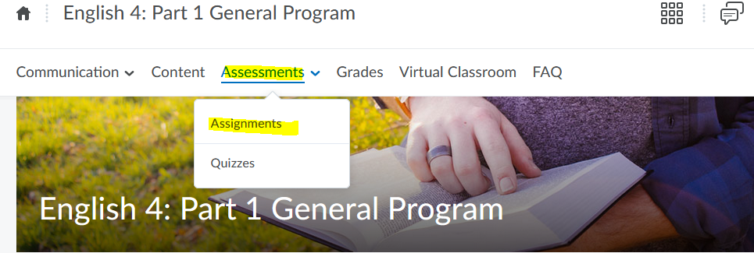
Lesson 3: Creative Archetype Assignment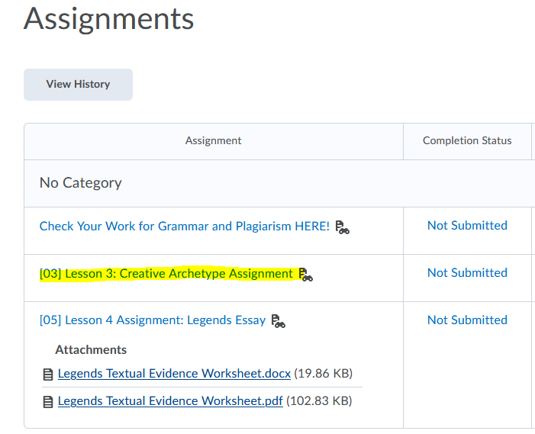
Prompt 1: Short Story
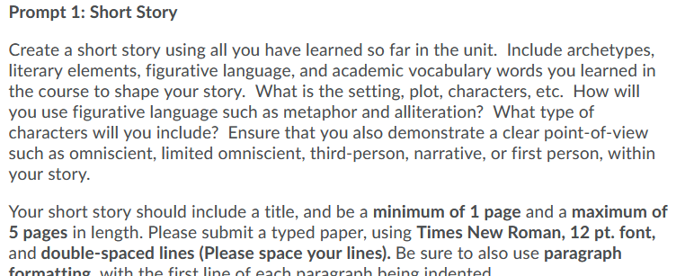

For all information needed on this short story can be found on the portal
Content
Lesson 3
